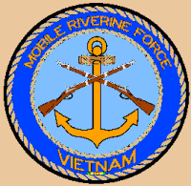

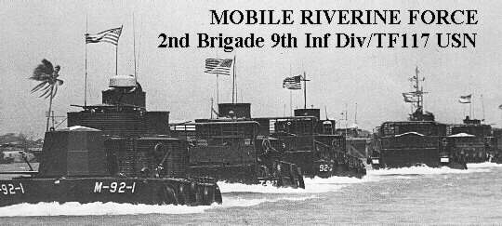

INTRODUCTION

This page is not intended as a detailed account nor as a history of the RIVERINE FORCE . It is here to show that apart from the "normal" fighting services in Vietnam (i.e. Sea, Land and Air) there was another - BROWN WATER WARFARE .Brown Water Warfare has been around since civilization began and will always be until civilization ends. In WW2 Brown Water Warfare was used in the Philippines to a modest extent. After WW2 it resurfaced in Indo China (Vietnam) as a French innovation and although successful it was very limited due to a lack of resources.

The main element of the French Brown Water Force was the "Dinassaut" (Naval Assault Division). The Dinassaut could never attain tactical surprise due to it's exposure, both visible and sound, on a waterway but it could attain strategic surprise. The main advantage the Viet Minh had was either the River Ambush or the placement of simple command detonated mines.

During 1950 the French began training South Vietnamese with the intent of creating the South Vietnamese Navy. In 1953 the first South Vietnamese Naval unit was activated. This unit was called the "Cantho Dinassaut" After the Geneva Accords (Indo China) in 1954 the South Vietnamese Navy comprised four "Dinassaut's" (hereafter called River Assault Groups (RAG's)), three Minesweepers (YMS) and three LCU's. By Nov 54 the RVN Navy had 130
Officers and 1370 enlisted men.. By 1965 the RVN Navy comprised two forces (1) Shore Component, (2) Sea Force , (3) Costal Force and (4) River Force. The River Force was comprised of six RAG,s with a total six Command/Control LCM-6(Modified), six "Monitor" LCM-6(Modified- the battleship of the River Force) 36 armoured LCM -6 and 36 LCVP. In

199 Peter James Bayliss, 1992

addition the River Force also included a River Transport Escort Group of four Monitors, six Patrol Boats and 20 armoured LCVP's. The River Transport Group (logistic) was equipped with seven LCU's

With the commitment of US combat and Logistic Forces in 1965 the VC had approx. 70000 combatants concentrated in the Mekong Delta (IV Corps). The general disposition of the VC was one Guerrilla squad per Hamlet, one Guerilla platoon per Village, one separate company per district and one battalion at the Province level. They were led by professionals, highly trained and well armed.

The IV Corps area contained the 7th, 9th and 21st Infantry Divisions of the South Vietnamese Army plus four Ranger battalions. Both the South Vietnamese River Force and the Infantry divisions could not wrest IV Corps from the VC. Many of the RVN units were poorly equipped To give some indication of the difficulties being experienced, IV Corps was the Mekong Delta and as such was known as the "rice Bowl" of Vietnam and was an exporter of rice yet in late 1965 the US began importing rice into Vietnam. It was estimated that 40% of the population in the Mekong Delta was under VC control/intimidation. The US Order Of Battle had allowed for an additional US Division to be deployed to South Vietnam. One of its Brigades was to be shore based at Vung Tau and one at My Tho and the third Brigade was to be based afloat in the Mekong Delta. The reality was that only one Brigade of the 9th Division was deployed - the 2nd Brigade.

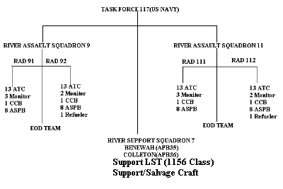

An Infantry Battalion of the 9th Division would be based afloat on the Benewah or the Colleton and the force would move on either the Bassac River or the Mekong River as required to a position which would then be the Mobile Base for operations. The 9th troops would then embark on Armoured Troop Carriers (ATC) and the River Assault Squadron (RAS) would then move to a local position to begin operations.

COMPOSITION OF RIVER FORCE

The main craft of the River Assault Squadron was the ATC which was a heavily modified WW2 LCM-6. All craft of the River Assault Squadron were modified LCM-6's except the ASPB which was purpose built.

The RAS would move out from the Mobile Base in Single File and craft would be in predetermined positions in that File. The following is an example of an RAS on Operations. :-
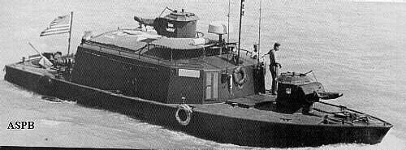

ASPB
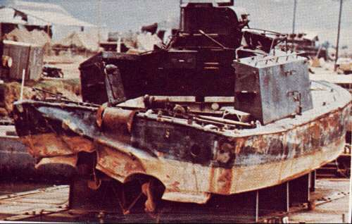

Damaged ASPB
The whole crew of this ASPB were either killed or wounded when a mine exploded under port side - aft.

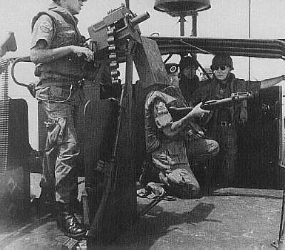
MK 18/19 LAUNCHER

This photograph is of a Rapid Fire Grenade launcher. The handle is wound as in a mince grinder and
40mm grenades are "sprayed" over a prescribed arc. Photo was taken aboard a Patrol Boat, River (PBR)

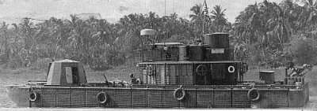
MRF MONITOR

The Monitor was the main Fire Support vessel of the MRF. Like the other craft of the MRF it was a heavily converted LCM-6. The armaments fitted were a 81mm mortar forward of the superstructure, A spoon shaped bow replaced the bow ramp of the ATC and on the bow was a
40mm cannon in an enclosed turret. Also fitted to the enclosed turret was a co-axial
.50cal HMG. Two MK18 grenade launchers were also carried. The organic weapons of the crew complemented the main armament. The Monitor was heavily armoured and often went very close to the riverbank to provide fire support to the troops on shore.

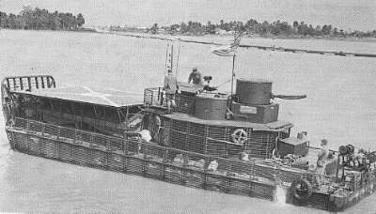
Armoured Troop Carrier (ATP)

The ATC is to Riverine Warfare that the APC is to the land based Infantry. It was in itself quite a formidable opponent. The ATC was armed with a 20mm cannon, 2 x 50 cal HMG, Two Mk18/19 grenade launchers plus crew weapons and the organic weapons carried by the Infantry. The max Infantry that could be carried was 40. Note the "Bar Armour" which surrounds the hull and upper deck. This was 1/2'' steel bar about a foot from the hull and was designed to detonate RPG's and recoilless rounds before hitting the hull and/or the upperdeck. Sometimes the protection worked and sometimes it did not. When it worked the casualties and damage was significantly reduced. Some were fitted with a Helipad fitted above the troop well. This was done to expedite transfer troops/ supply delivery. some were designated ATC (H) and were fitted out as Battalion Aid Stations.
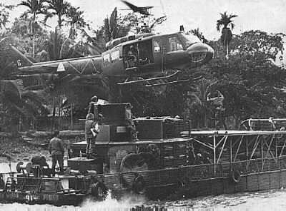

ATC Chopper Pad

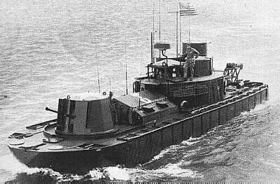
Command Control Boat (CCB)

The CCB provided Command and Communications facilities for the ground force and Boat Group commanders. They were heavily armoured. Armament was 1x40mm, 1x20mm, 2 x.50cal HMG, 2 x .30 cal MMG and four Mk 18 grenade launchers.
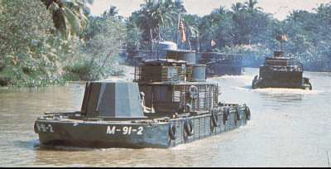

The photograph displays MRF craft on operations

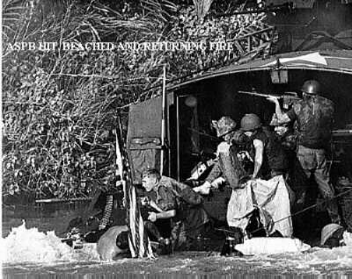
ASPB Hit
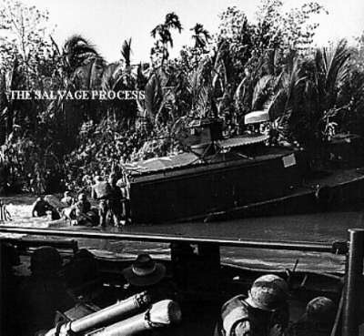

ASPB Salvage

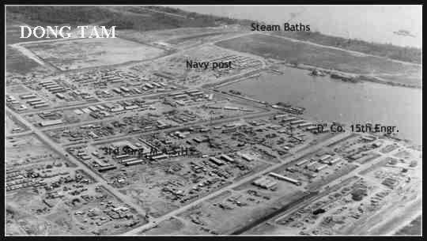
Mobile Riverine Force Base at Dong Tam Harbour

The entry of US Combat Forces to the Mekong Delta had been discussed as early as 1965. By
1966 the decision to put troops there had been decided in the positive, but as to where was not decided until later. The Dong Tam area was finally decided upon and for the area to have total security it remained for the Logistic requirements to be met. It was then decided to make a harbour. Literally, a small dredge was bought in to make a hole big enough for a big dredge
and the big dredge "dug a bloody big hole" and US Army Engineers, US Navy CB's (Seabees)
with a US civil company - PA & E- did the rest.

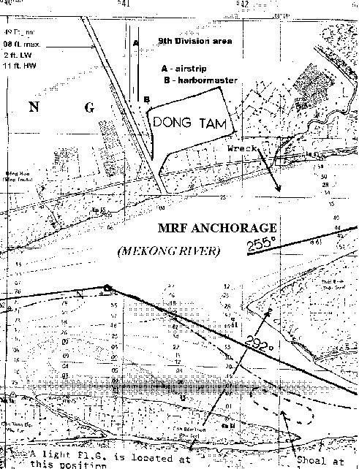

. Insertion: An ASPB alongside an ATC which is inserting 9th Inf Div troops
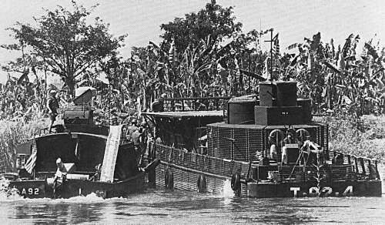

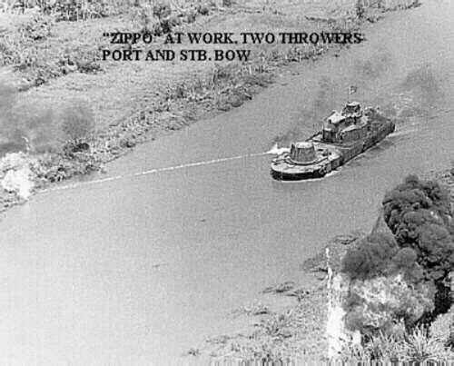
Zippo

. A River Assault Squadron en-route to assault area
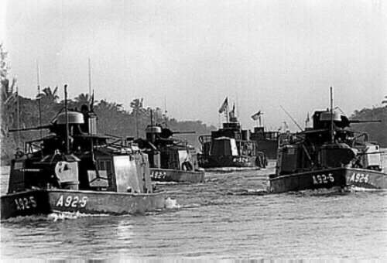

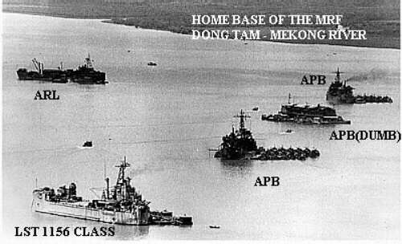
Mobile Riverine Force “At Anchor”

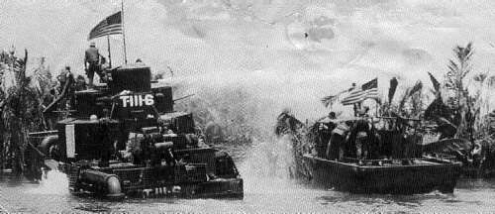.
A MRF water monitor. This craft was used to destroy tunnel entrances at the river/canal bank.

.
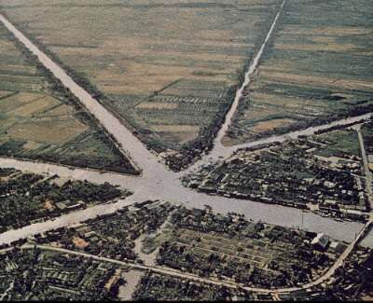

The above photo is of Phan Phiep and shows the manmade canals that interlace the Mekong Delta and complement the Mekong/Bassac river and tributaries. The canals provide a means of transporting local agricultural products to Saigon and also provide a method of drainage to the Mekong/Bassac during the "Wet Season". The MRF operated in this environment , but even with all their resources could not wrest control from the VC. However, they did make a sizeable dent in VC activity. The number of man-made canals in the Mekong Delta is very large and some run for distances exceeding 40 miles in a straight line. I do have a map of the Waterways and Canals but in scanning the background merges with the foreground making it impossible to view it the way it should be viewed.
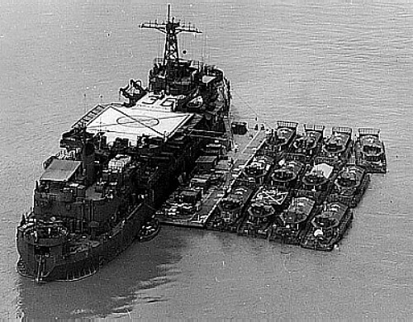

APB 36 "COLLETON"

APB36 "COLLETON" was one of two APB's allocated to the MRF. Both were built as LST's and later converted to Self-Propelled Barrack ships. The original concept of MRF Tactical Operations was five days but was reduced to two days followed by one day rest. This was due to the debilitating effect of the delta itself and the Riverine environment on men and equipment. The original concept had the Mobile Base moving every six weeks but this was reduced to 12/14 days. APB 39 "MERCER" and APB 40 "NUECES" were "slotted' for Vietnam in 1968 but, I saw neither.

APB 35 and APB 36 displaced 4080 tons Full Load, 200 crew and 900 troops could be accommodated. Their evaporators could produce 40,000 gallons of fresh water daily. A sixteen bed hospital, X-ray facilities, Dental facilities, Bacteriological laboratory, Pharmacy, Laundry, Library and tailor shop. All living spaces and most working areas were air conditioned. They were armed with two 3" guns (single), 8 x 40mm (two quad positions), 8 x
.50 cal HMG and 10 x .30cal MMG.
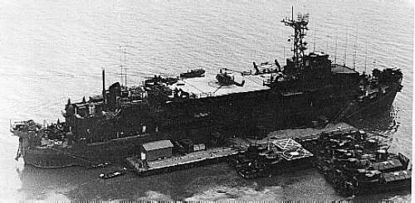

APB 35 "BENEWAH"

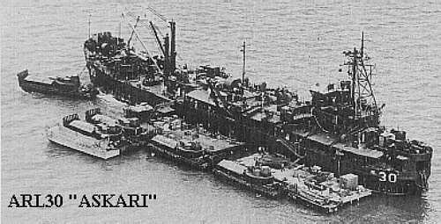
ARL 30 "ASKARI"

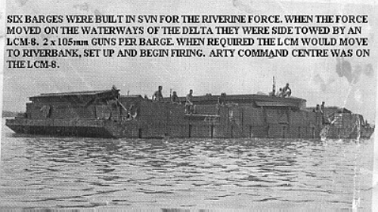
Gun Barge

Six Barges were constructed at Cam Ranh Bay for the MRF. They would be side towed by an LCM-8 with the main force and when required would moor to the riverbank, set up and begin firing. Each Barge carried 2 x 105mm guns with the Control centre carried aboard the LCM-
8.The ground troops would never be outside the range of the guns. An earlier version of the gun barge was a platform which was placed at the riverbank on hydraulic legs, but from a mobility perspective was not as versatile as the later concept.

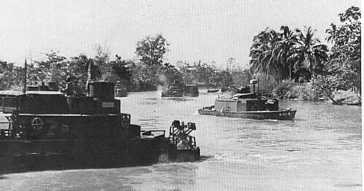
TACTICAL LANDING: Insertion Point - The odds of inserting troops in a "Soft Zone" are always in favour of the MRF --- but every now and then.............

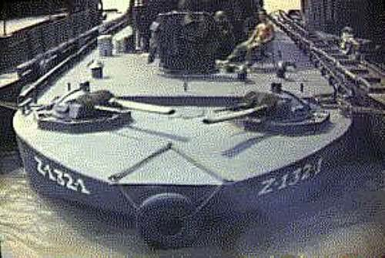
Zippo Flame Thrower
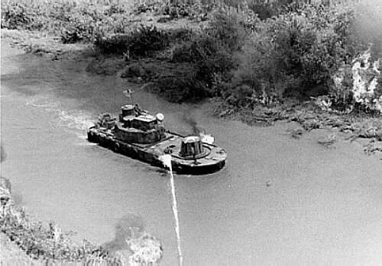

Zippo at work

. On the 5th July 1970 ARL 38 "KRISHNA" was mined.
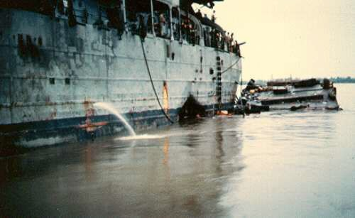

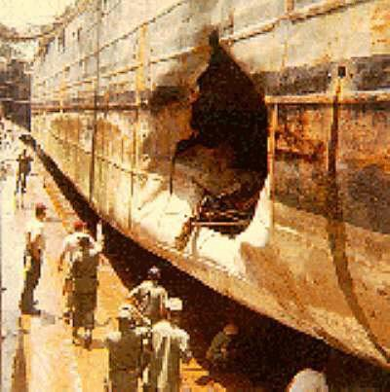

Mine damage

